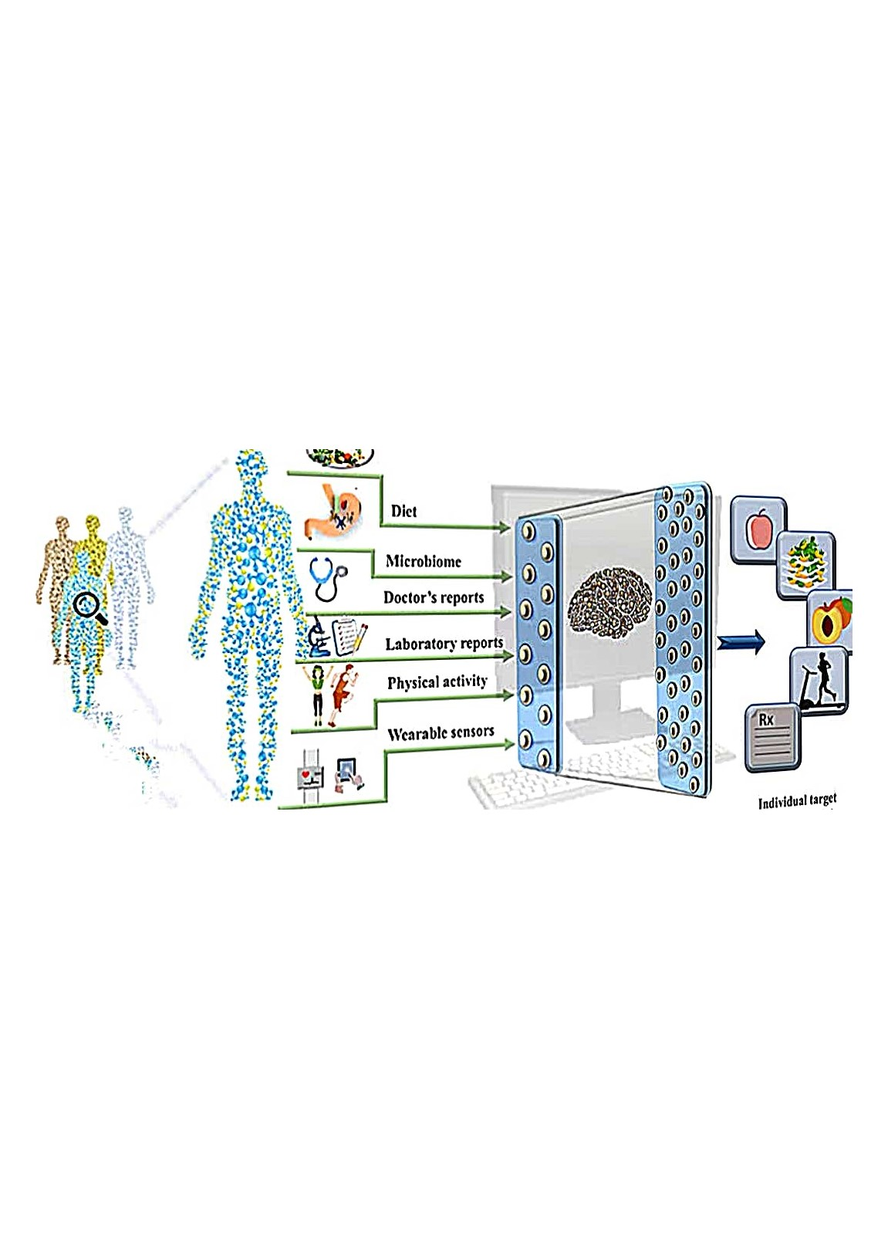

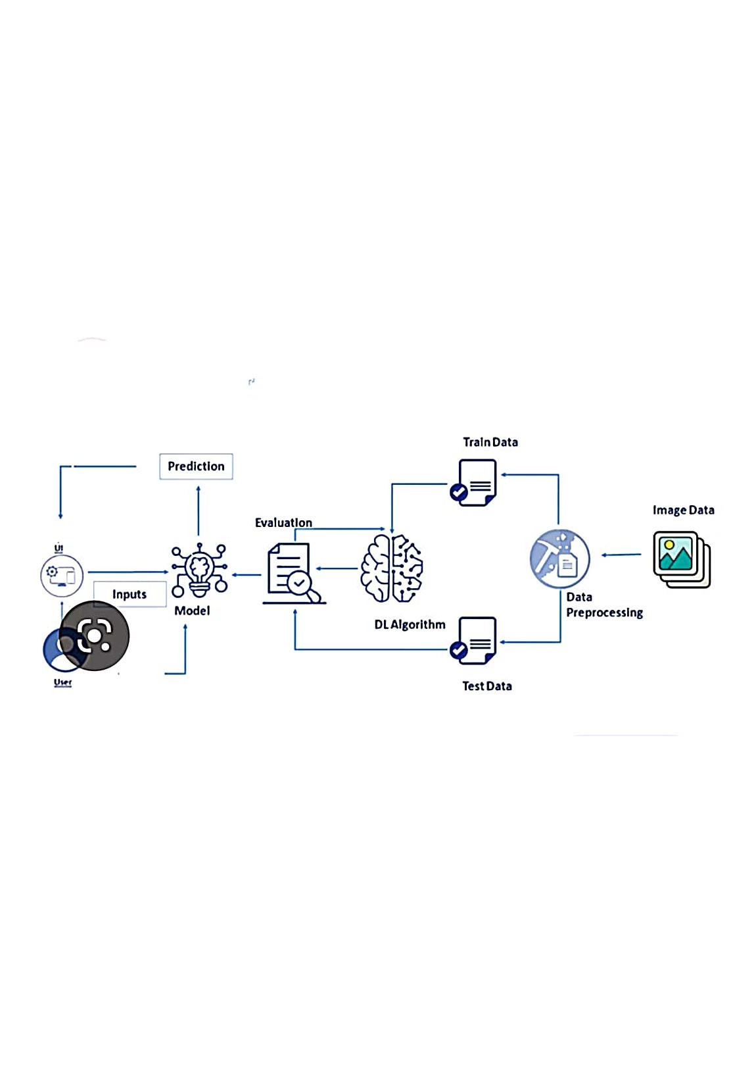

Data

TestData

Train

Data

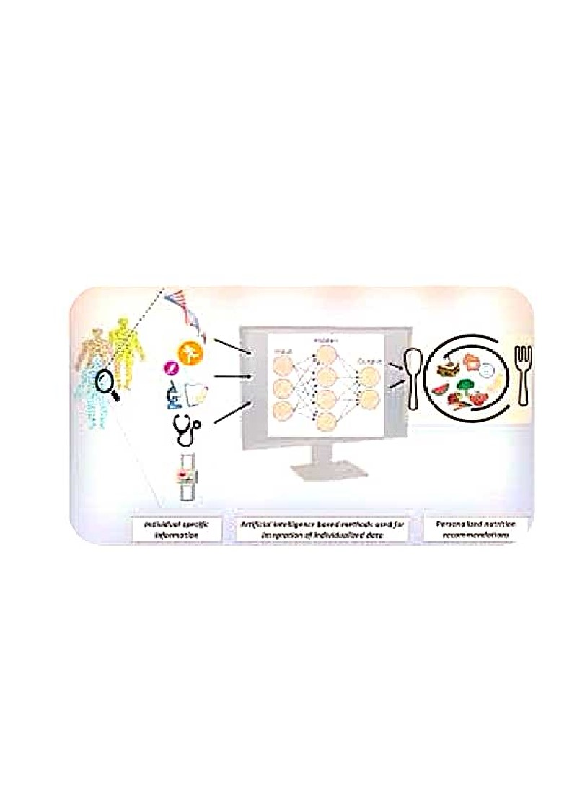

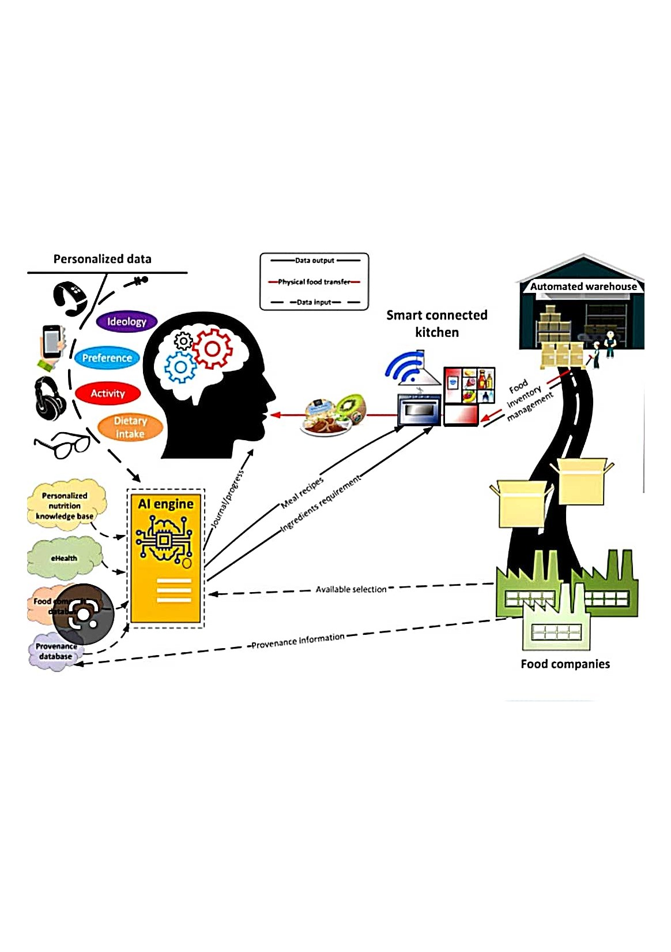

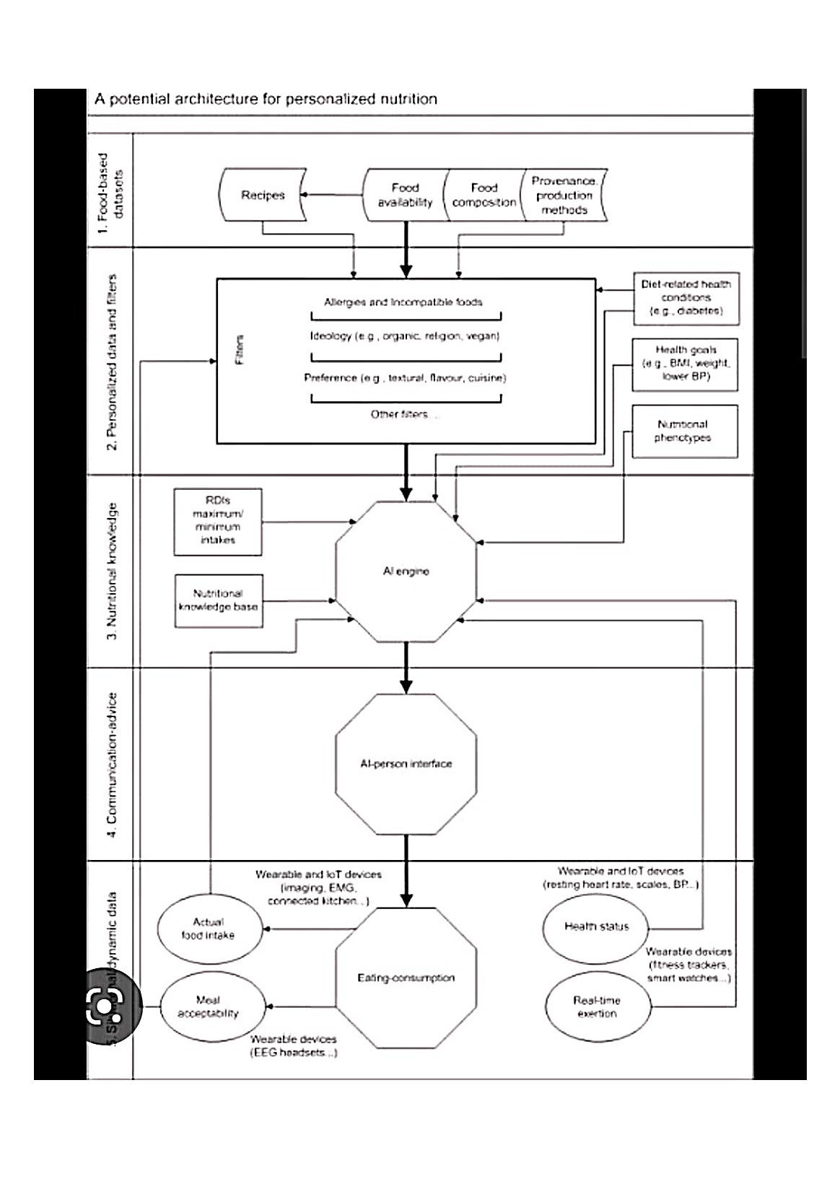

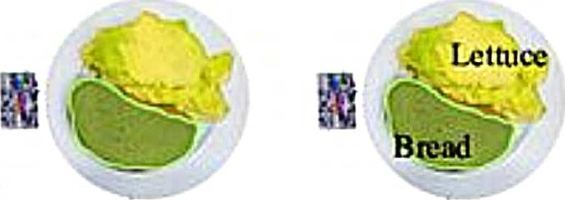

|  |  |  |
| --- | --- | --- |
| segmentation |  | Food recognition |
|
|

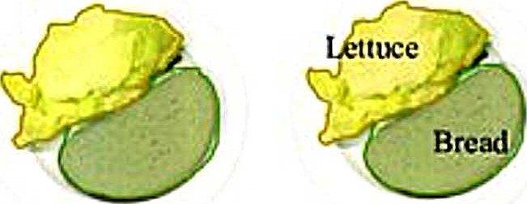

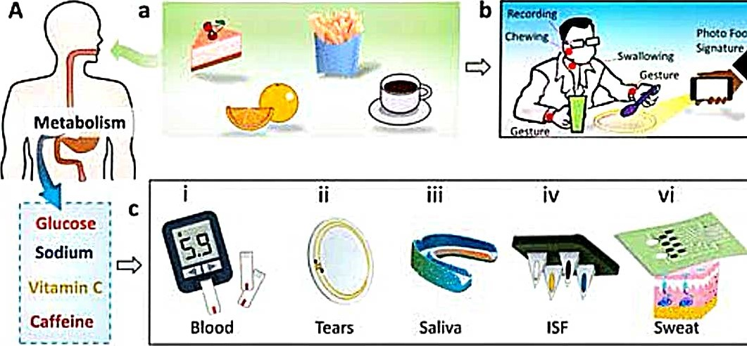

|  |  |  |
| --- | --- | --- |
| Analysis of image  • and physical parameters  Biosensor | b |  |
|
|
| 8 am noon 8 pm |

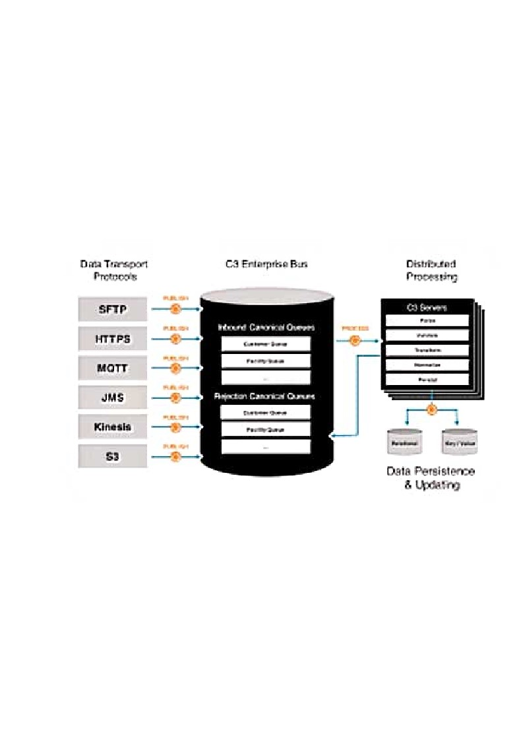

П

гю

Тыг•дке1

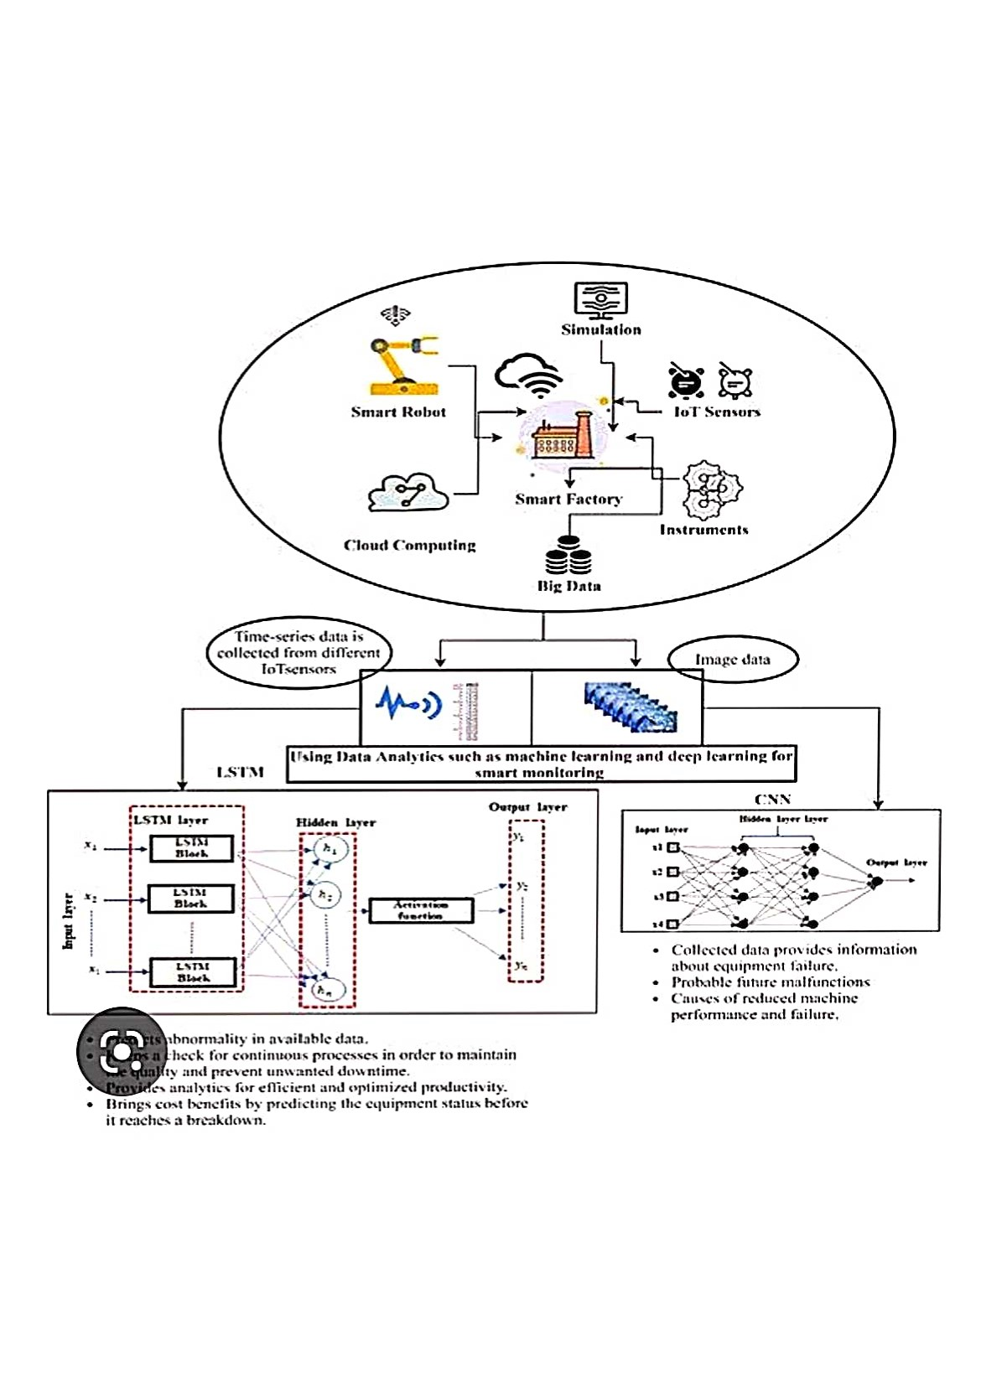

cost

benefits

by

predicting

the

equipment

status

tx•fore

Brings

it

reaches

a

breakdoun.

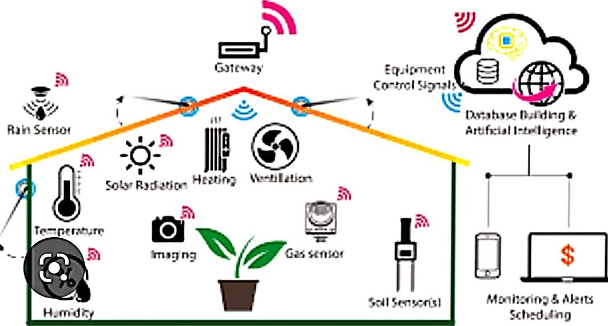

IOT, big data and artificial intelligence

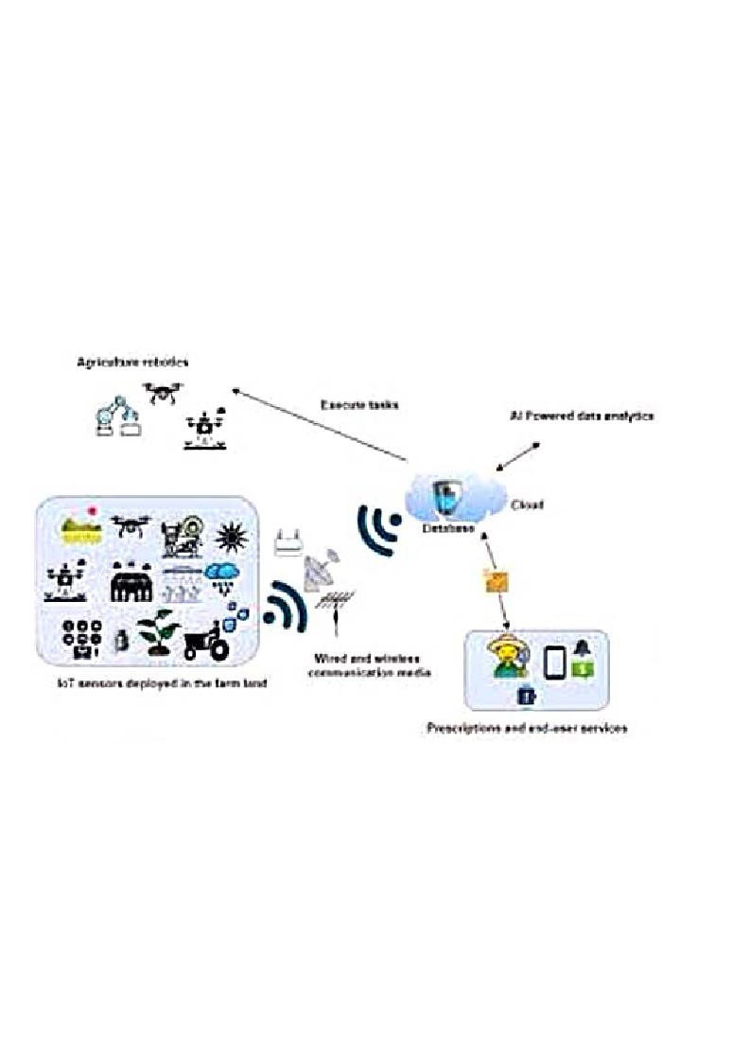

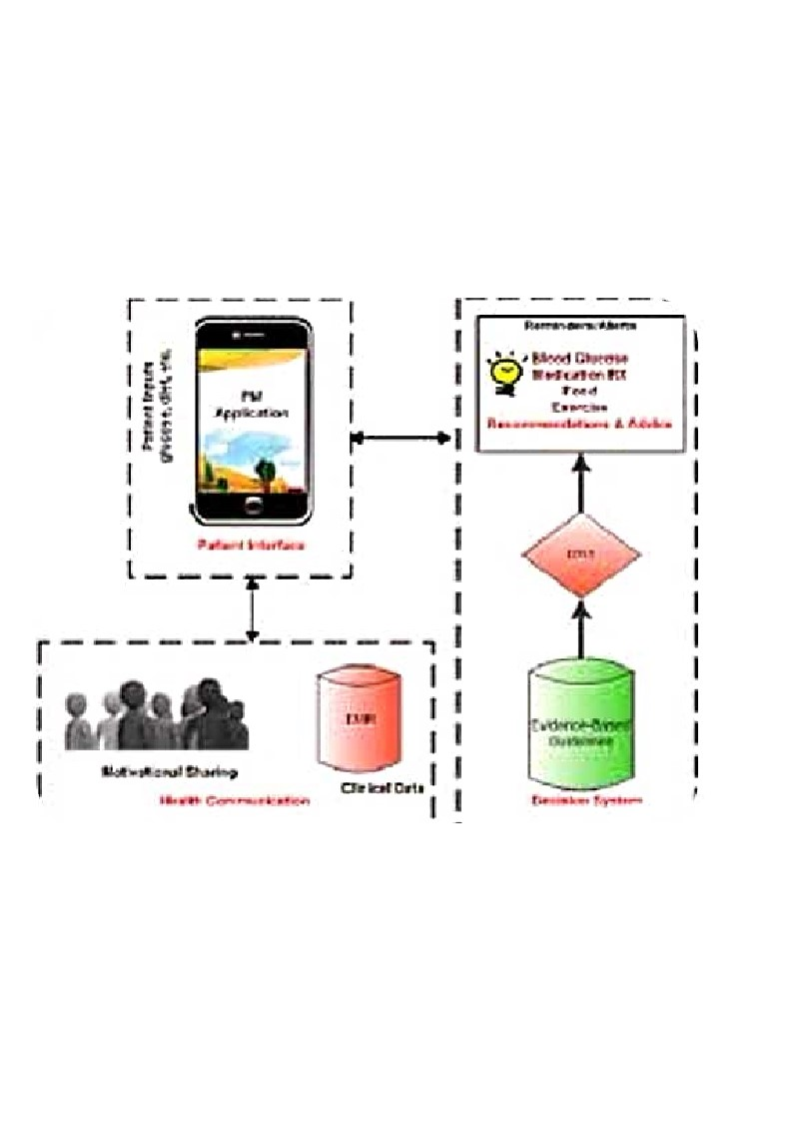

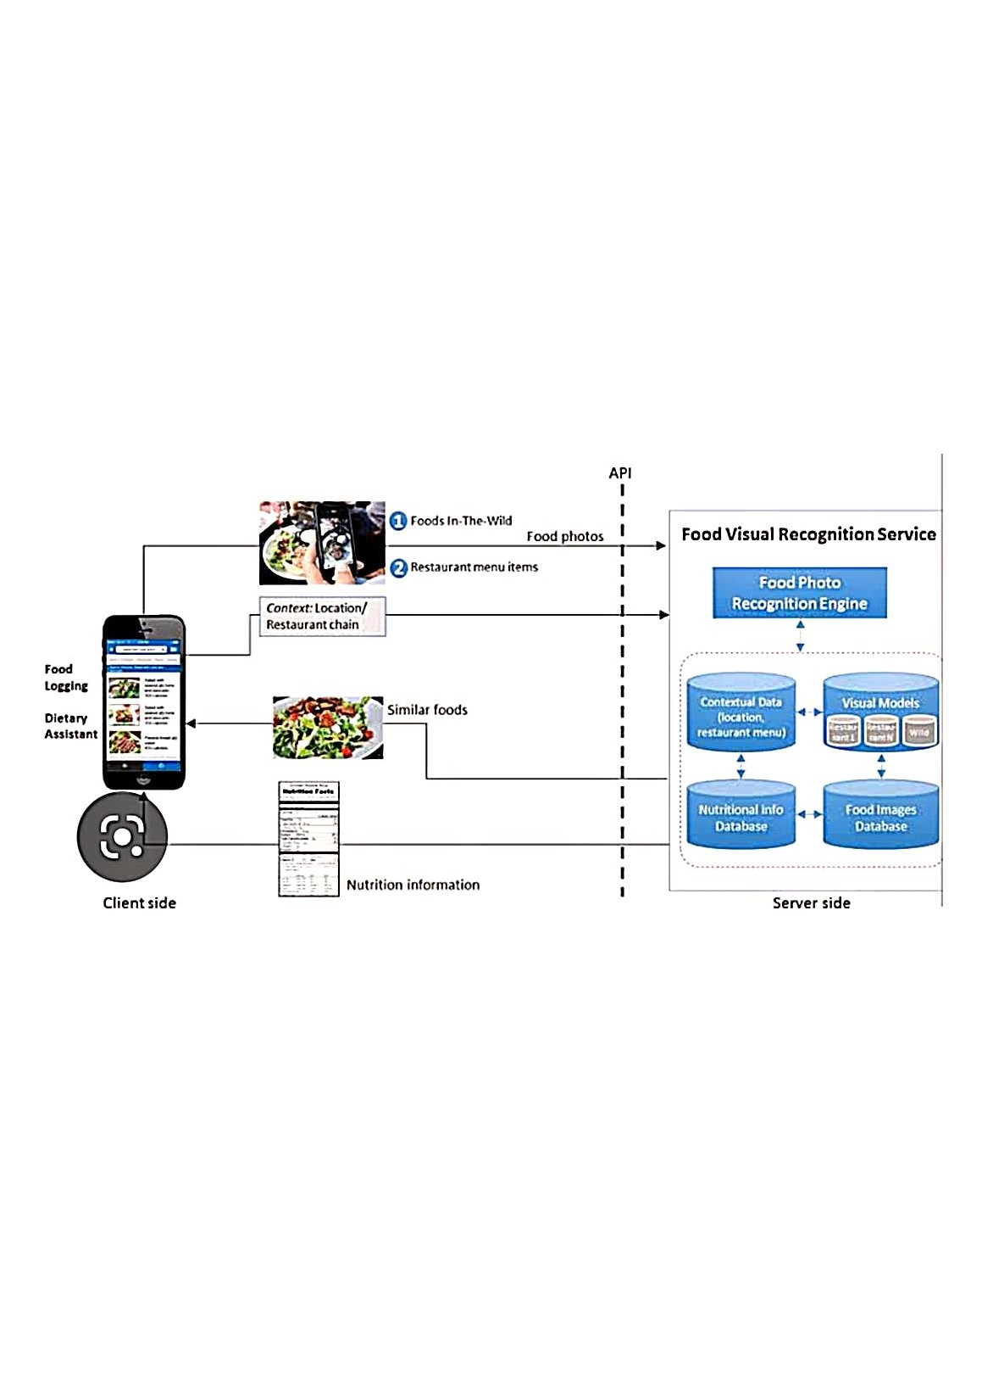

Client

side

Server

side

Food

Locglng

Dietary

Assistant